**NAME: PREETI  PALLAVI**

CASE STUDY: ORANGE HRM

Github url: [preeti122/orangeHRM\_CW (github.com)](https://github.com/preeti122/orangeHRM_CW)

**User Story 1 - US\_001: Create New User**

As a new user, I want to create a new user in the system,   
so that the new employee can access the OrangeHRM application with appropriate permissions.

**Acceptance Criteria:**

* Given I am logged in as an Admin, when I navigate to the User Management section, then I should see an option to add a new user.
* Given I am on the Add New User page, when I enter the required details (e.g., username, password, employee name, user role, status), then I should be able to save the new user.
* Given I have entered all required details correctly, when I click the ‘Save’ button,   
  then the new user should be created and listed in the User Management section.
* Given I have created a new user, when I navigate back to the User Management section, then I should see the new user in the list with the correct details.

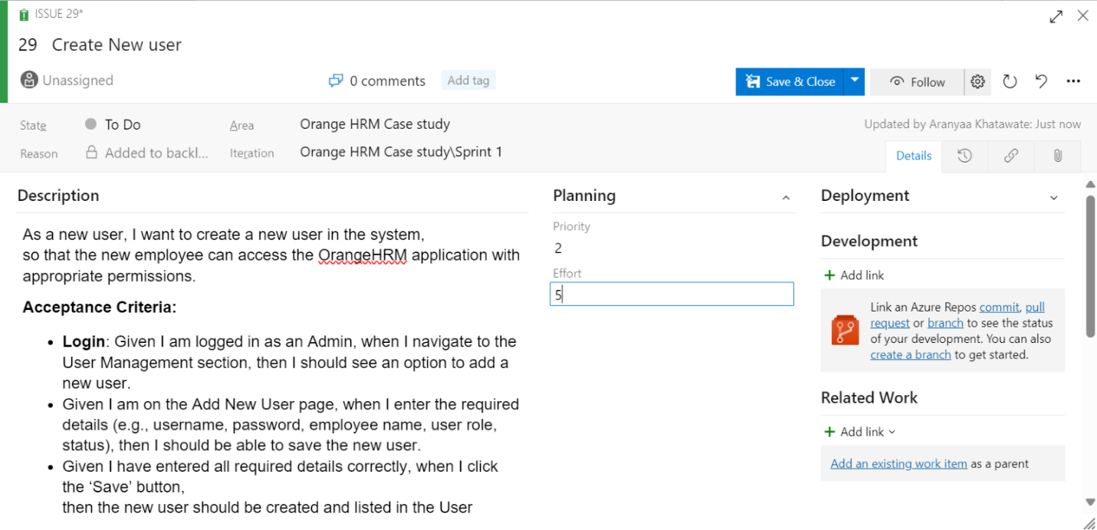

**TEST CASES:**

**TC\_001: Verify Admin Can Access Add New User Page**

Description: To test if the Admin can access the Add New User page.

Given the Admin can access the OrangeHRM application and logs in using ‘Admin’ username and ‘admin123’ password,   
When the Admin navigates to the User Management section and clicks on the “Add New User” button,   
Then the Admin should be able to view the Add New User page.

**TC\_002: Verify New User Creation with Valid Data**

Description: To test if a new user can be created with valid data.

Given the Admin is on the Add New User page,   
When the Admin enters valid data (refer table) and clicks the “Save” button,   
Then the new user should be created successfully and listed in the User Management section with the correct details.

|  |  |
| --- | --- |
| Username | Jdoe |
| Password | Pwd123 |
| Employee name | John War |
| Role | ESS |
| Status | Enabled |

**TC\_003: Verify Unique Username Validation**

Description: To test the validation for unique usernames.

Given the Admin is on the Add New User page,   
When the Admin enters a username that is already in use and clicks the “Save” button,   
Then the system should display an error message indicating that the username is already taken.

|  |  |
| --- | --- |
| Username | existing\_user |
| Password | Pwda123 |
| Employee name | John War |
| Role | Admin |
| Status | Enabled |

**TC\_004: Verify Password Complexity Requirements**

Description: To test the password complexity requirements.

Given the Admin is on the Add New User page,   
When the Admin enters a password that does not meet complexity requirements and clicks the “Save” button,   
Then the system should display an error message indicating that the password does not meet the security requirements.

|  |  |
| --- | --- |
| Username | new\_user |
| Password | Pwdan123 |
| Employee name | Alice Johnson |
| Role | Admin |
| Status | Enabled |

**TC\_005: Verify User Role Assignment**

Description: To test if the user role is assigned correctly.

Given the Admin is on the Add New User page,   
When the Admin enters valid data and clicks the “Save” button,   
Then the new user should be listed with the correct user role (Manager) and should have the appropriate permissions based on the assigned role.

|  |  |
| --- | --- |
| Username | mng\_user |
| Password | Pwda123 |
| Employee name | Bob War |
| Role | Manager |
| Status | Enabled |

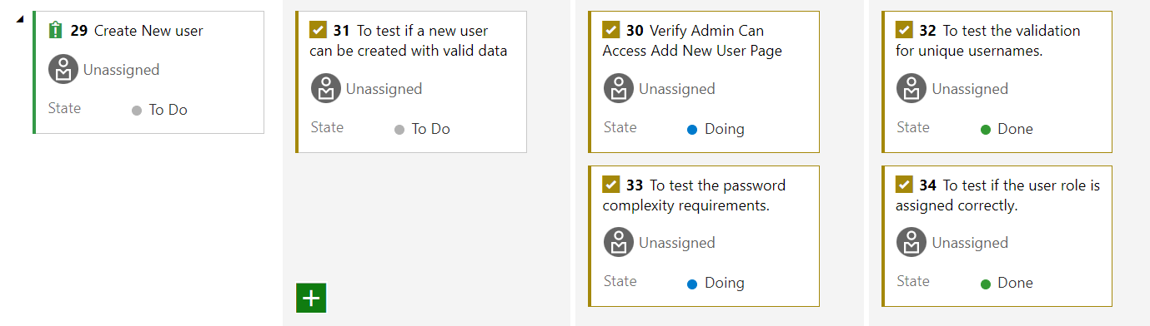

**USER STORY 2 - US\_002:** As a user, when I go to Job Titles under Jobs dropdown in Admin tab, I should be able to add, edit, delete jobs.

**Acceptance Criteria:** When the user goes to Admin tab and clicks on Job titles under Jobs dropdown,

* The system should display all the jobs currently listed in the portal
* The system should allow the user to add a new job title with the description
* The system should allow the user to edit as well as delete existing job titles

Effort: 4

Priority: 2

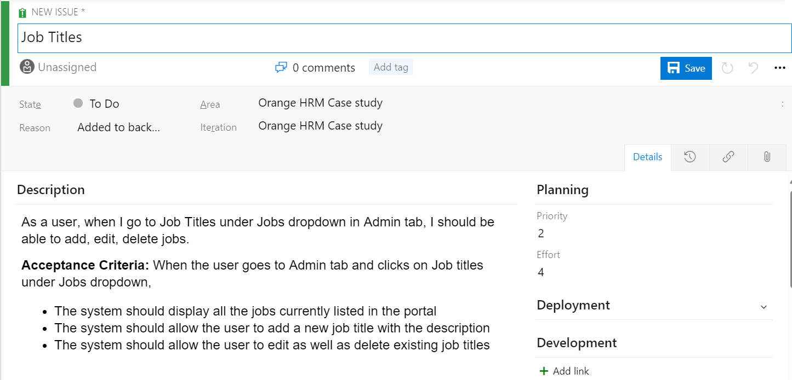

**TEST CASES**

**TC\_006: Verify Admin Can Access Job Titles Page**

Description: To test if the Admin can access the Job Titles page.

Given the Admin can access the OrangeHRM application and logs in using admin username and admin\_password password,   
When the Admin navigates to the Jobs section and clicks on the “Job Titles” option,   
Then the Admin should be able to view the Job Titles page.

**TC\_007: Verify Adding a New Job Title with Valid Data**

Description: To test if a new job title can be added with valid data.

Given the Admin is on the Job Titles page,   
When the Admin clicks on the “Add” button, enters valid data (refer table) and clicks the “Save” button,   
Then the new job title should be added successfully and listed on the Job Titles page.

|  |  |
| --- | --- |
| Job title | Software Engineer |
| Job desc | Develops software applications |
| Job spec | specification.pdf |
| Note | N/A |

**TC\_008: Verify Job Title Duplication Validation**

Description: To test the validation for duplicate job titles.

Given the Admin is on the Job Titles page,   
When the Admin clicks on the “Add” button, enters a job title that already exists (Job Title: Software Engineer, Job Description: Develops software applications, Job Specification: specification.pdf, Note: N/A) and clicks the “Save” button,   
Then the system should display an error message indicating that the job title already exists.

**TC\_009: Verify Editing an Existing Job Title**

Description: To test if an existing job title can be edited.

Given the Admin is on the Job Titles page,   
When the Admin selects an existing job title (e.g., Software Engineer), clicks on the “Edit” button, modifies the job description (e.g., Develops and maintains software applications), and clicks the “Save” button,   
Then the job title should be updated successfully with the new details.

**TC\_010: Verify Deleting a Job Title**

Description: To test if a job title can be deleted.

Given the Admin is on the Job Titles page,   
When the Admin selects an existing job title (e.g., Software Engineer), clicks on the “Delete” button, and confirms the deletion,   
Then the job title should be removed from the list and no longer visible on the Job Titles page.

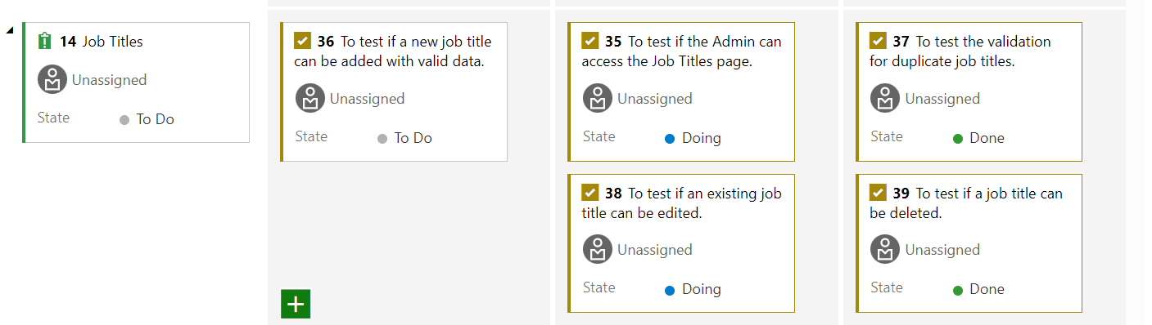

**USER STORY\_003: Login Page**

As a user when I enter valid username and password and click on the Login button, then the system should allow me to access the home page.

Acceptance Criteria: When valid credentials are entered, the system should

* Allow the user to access the home page.
* Username should be of 5-20 characters.
* Password should contain alphanumeric values with at least 1 digit and 1 small case.

Priority: 1

Effort: 3

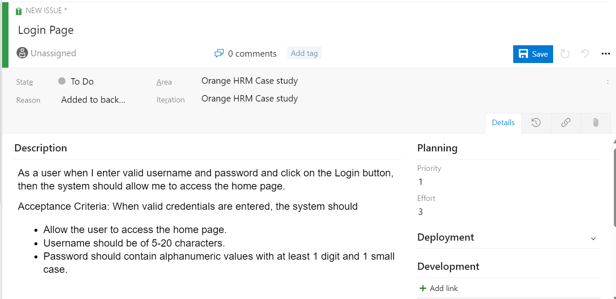

**TC\_011:** To test the login functionality of login page using valid credentials

Given the user can access the application  [OrangeHRM (orangehrmlive.com)](https://opensource-demo.orangehrmlive.com/web/index.php/pim/configurePim" \t "_blank) in chrome browser

When user enters valid "username" and valid "password"

And user clicks on login button

Then the user should be redirected to the [Dashboard](https://opensource-demo.orangehrmlive.com/web/index.php/dashboard/index)

|  |  |  |  |  |
| --- | --- | --- | --- | --- |
| **S. No.** | **Username** | **Password** | **Able to login?** | **Expected Outcome** |
| 1 | Admin | admin123 | Yes | Yes |

**TC\_012:** To test if username field is editable and if the user can enter text

Given the user can access the application [OrangeHRM (orangehrmlive.com)](https://opensource-demo.orangehrmlive.com/web/index.php/pim/configurePim" \t "_blank) in chrome browser

When user clicks on the “username” field

Then the user should be able to enter the “username”.

|  |  |
| --- | --- |
| **S. No.** | **Username** |
| 1 | Admin |
| 2 | Admin123 |

**TC\_013:** To test if password field is editable and if the user can enter text

Given the user can access the application [OrangeHRM (orangehrmlive.com)](https://opensource-demo.orangehrmlive.com/web/index.php/pim/configurePim) in chrome browser

When user clicks on the “password” field

Then the user should be able to enter the “password”.

|  |  |
| --- | --- |
| **S. No.** | **Password** |
| 1 | admin123 |

**TC\_014:** To test if a relevant message is displayed when invalid credentials are entered.

Given the user can access the application [OrangeHRM (orangehrmlive.com)](https://opensource-demo.orangehrmlive.com/web/index.php/pim/configurePim) in chrome browser

When user enters invalid "username" or invalid "password"

And user clicks on login button

Then the user should get a message stating “Invalid credentials” above the username field.

|  |  |  |
| --- | --- | --- |
| **S. No.** | **Username** | **Password** |
| 1 | Admin | admin123 |

**TC\_015:** To test the login functionality with an empty username or empty password.

Given the user can access the application [OrangeHRM (orangehrmlive.com)](https://opensource-demo.orangehrmlive.com/web/index.php/pim/configurePim) in chrome browser

When user enters empty "username" or empty "password"

And user clicks on login button

Then the user should get a message stating “Required” below the respective empty field.

|  |  |  |
| --- | --- | --- |
| **S. No.** | **Username** | **Password** |
| 1 |  | admin123 |
| 2 | Source |  |

**TC\_016:** To test the login functionality with an invalid username or invalid passoword.

Given the user can access the application [OrangeHRM (orangehrmlive.com)](https://opensource-demo.orangehrmlive.com/web/index.php/pim/configurePim) in chrome browser

When user enters invalid "username" or invalid "password"

And user clicks on login button

Then the user should get a message stating “Invalid credentials”.

|  |  |  |  |  |
| --- | --- | --- | --- | --- |
| **S. No.** | **Username** | **Password** | **Actual outcome** | **Expected outcome** |
| 1 | admin | admin123 | Yes | No |
| 2 | Source | admin | No | No |

**Bug Report (BR\_010):**

* **Description of bug:** Login successful with invalid credentials
* **Steps to reproduce:** Open OrangeHRM  in chrome browser, enter “admin” username and “admin123” password and click on login button. The user is able to successfully login
* **Time stamp:** 06/09/2024 12:50 PM
* **Severity: High**
* **Priority:** Major
* **Assignee:** Developer3
* **Screenshot**

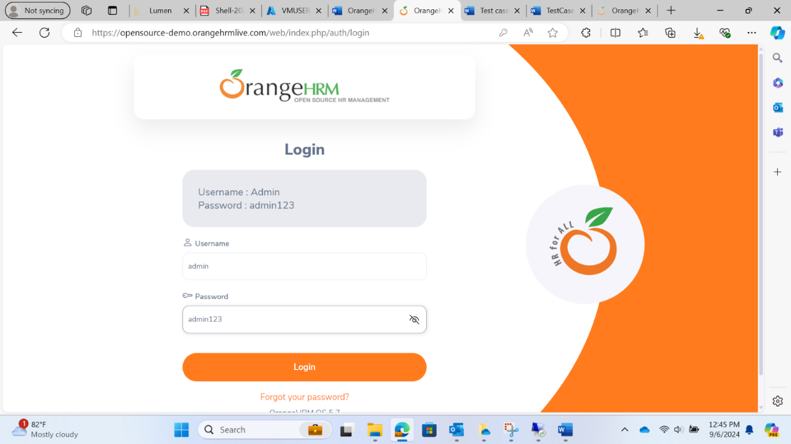

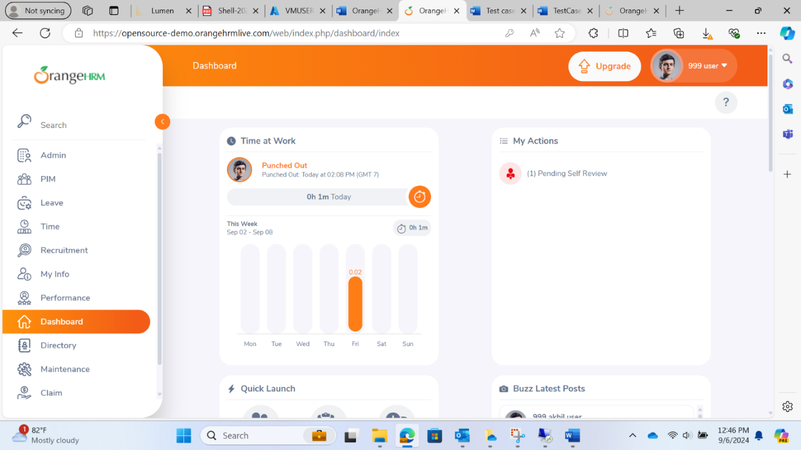

**USER\_STORY\_004: Optional Fields in Configuration**

As a user when I go to Optional Field in the dropdown menu of Configuration in PIM tab from Menu, then the system should allow me an option to “Show Deprecated Fields” and “Country Specific Information” or not.

Acceptance Criteria: When the Optional Field is selected from the dropdown menu of Configuration in PIM tab from Menu, the system should

* Allow the user to access the optional field page.
* A toggle button to “Show Deprecated Fields” or not.
* A toggle button to “Country Specific Information” or not.

Priority: 3

Effort: 2

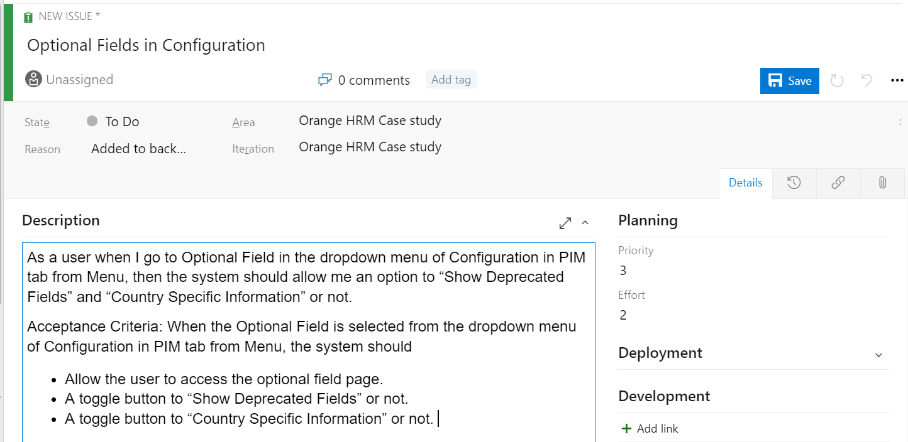

**TC\_017:** To test if the Optional Field Page can be accessed by clicking on Optional Fields in Configuration drop down

Given the user is logged in as an admin

When the user navigates to the "Configuration" dropdown menu in the "PIM" tab

And the user selects "Optional Field"

Then the system should allow the user to access the optional field page   
   
**TC\_018:** To test the functionality of “Show Nick Name, Smoker and Military Service in Personal Details” Toggle Button

Given the user is on the optional field page

When the user clicks on the toggle button of “Show Nick Name, Smoker and Military Service in Personal Details”

Then the system should allow the user to hide or show deprecated fields.

**TC\_019:** To test the functionality of “Show SSN field in Personal Details” Toggle Button

Given the user is on the optional field page

When the user clicks on the toggle button of “Show SSN field in Personal Details”

Then the system should allow the user to hide or show SSN field in Personal Details. 

**TC\_020:** To test the functionality of “Show SIN field in Personal Details” Toggle Button

Given the user is on the optional field page

When the user clicks on the toggle button of “Show SIN field in Personal Details”

Then the system should allow the user to hide or show SIN field in Personal Details. 

**TC\_021:** To test the functionality of “Show US Tax Exemptions menu” Toggle Button

Given the user is on the optional field page

When the user clicks on the toggle button of “Show US Tax Exemptions menu”

Then the system should allow the user to hide or show US Tax Exemptions menu.

**TC\_022:** To test the functionality of “Save” Button

Given the user is on the optional field page

When the user clicks on the toggle button of fields as per requirement

And clicks on the “Save” button

Then the system should save the details

And show a message “Successfully saved”.

**USER\_STORY\_003:** Manage User Accounts in Admin Module

As a user, when I go to Admin->User management page of OrangeHRM application, the system should allow me to add, edit, and delete user accounts efficiently.

Acceptance Criteria:

* The system should allow the admin to access the User Management page from the Admin module.
* The system should provide options to add a new user, edit existing user details, and delete user accounts.
* The system should validate user input and display appropriate error messages for invalid data.
* The system should display a confirmation prompt before deleting a user account.
* The system should update the user list in real-time after any changes are made.

Prirority: 1

Effort: 4

**TC\_023:** To test if the User Management page in Admin Module is accessible or not. 

Given the admin is logged in

When the admin navigates to the "Admin" module   
And the admin selects "User Management"   
Then the system should display the User Management page   
   
**TC\_024:** To test if a new user is being added or not.

Given the admin is on the User Management page

When the admin clicks on the "Add" button

And the admin enters valid user details

And the admin clicks on the "Save" button

Then the system should add the new user and display a success message

And the new user should appear in the user list   
   
**TC\_025:** To check if a new user can be edited or not.

Given the admin is on the User Management page

And there is at least one user in the user list

When the admin selects a user and clicks on the "Edit" button

And the admin updates the user details

And the admin clicks on the "Save" button

Then the system should update the user details and display a success message

And the updated user details should appear in the user list   
   
 **TC\_026: Delete User**   
  Given the admin is on the User Management page   
   And there is at least one user in the user list   
   When the admin selects a user and clicks on the "Delete" button   
   Then the system should display a confirmation prompt   
   When the admin confirms the deletion   
   Then the system should delete the user and display a success message   
   And the user should be removed from the user list

   
 **TC\_027: Input Validation for Adding User**   
   Given the admin is on the User Management page   
   When the admin clicks on the "Add" button   
   And the admin enters invalid user details (e.g., missing required fields)   
   And the admin clicks on the "Save" button   
   Then the system should display appropriate error messages for the invalid input   
   And the user should not be added to the user list

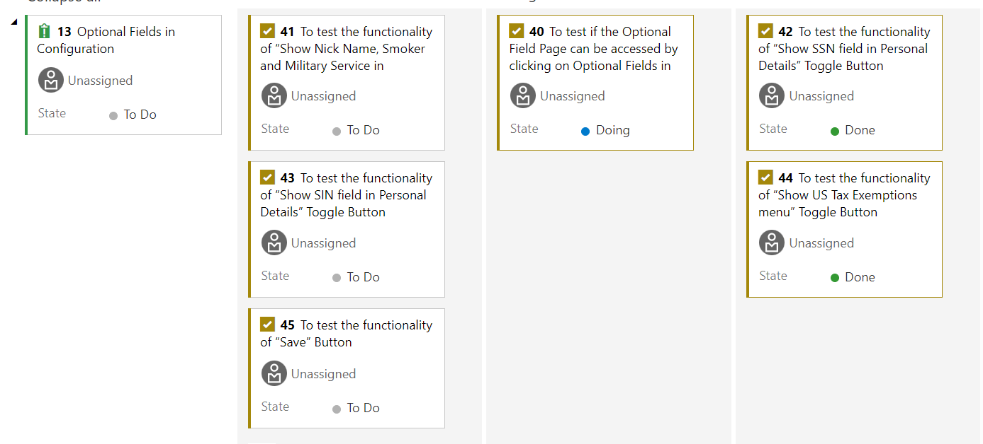

**US\_005: TERMINATION REASONS**

As a user when I go to “Termination Reasons” under “configuration” toggle under “PIM” tab then I should be able to add, edit and delete the termination terms of any employee.

**Acceptance Criteria:** When valid credentials are entered and select “Termination Reasons” page then:

* User should be able to add “Termination Reason” to the list.
* User should be able to edit the “Termination Reason” record of the employee.
* User should be able to delete the “Termination Reason” record of any employee.

Priority: 1

Effort: 4

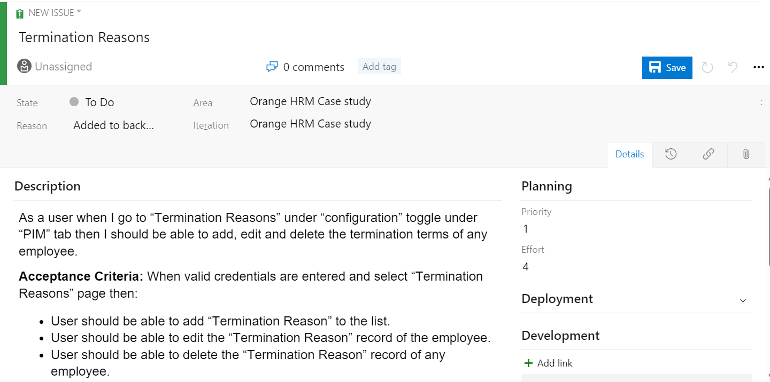

TC\_028

Description: To validate the functionality of the “Add” button

Given the user is logged in to the website “https://opensource-demo.orangehrmlive.com/web/index.php/auth/login” in chrome web browser using the valid username “Admin” and valid password “admin123” and he is in the “Termination Reasons” tab under “Configuration” dropdown in “PIM” tab.

When the user clicks on the “Add” button

Then the user should be redirected to the page (https://opensource-demo.orangehrmlive.com/web/index.php/pim/saveTerminationReasons) which asks the user to type in the termination reason.

**Bug Report**

Description: The field ask for Name on termination reason page instead of reason which may create a confusion

**Steps to reproduce:**

* Open chrome browser
* Open the site https://opensource-demo.orangehrmlive.com/web/index.php/auth/login
* Login using username: ‘Admin’ and password: admin123
* From the list select ‘PIM’ then go to ‘Configuration’ then go to ‘Termination Reason’ and click on ‘Add’ button. The input field is showing to input ‘Name’ instead it should ask to enter the ‘Reason’

Time Stamp: 06/09/2024 10:55 AM

Severity:  Low

Priority: Minor

Assignee: problem\_dev

Expected Result: The user should be asked to enter Reason instead of Name.

Screenshot or recording:

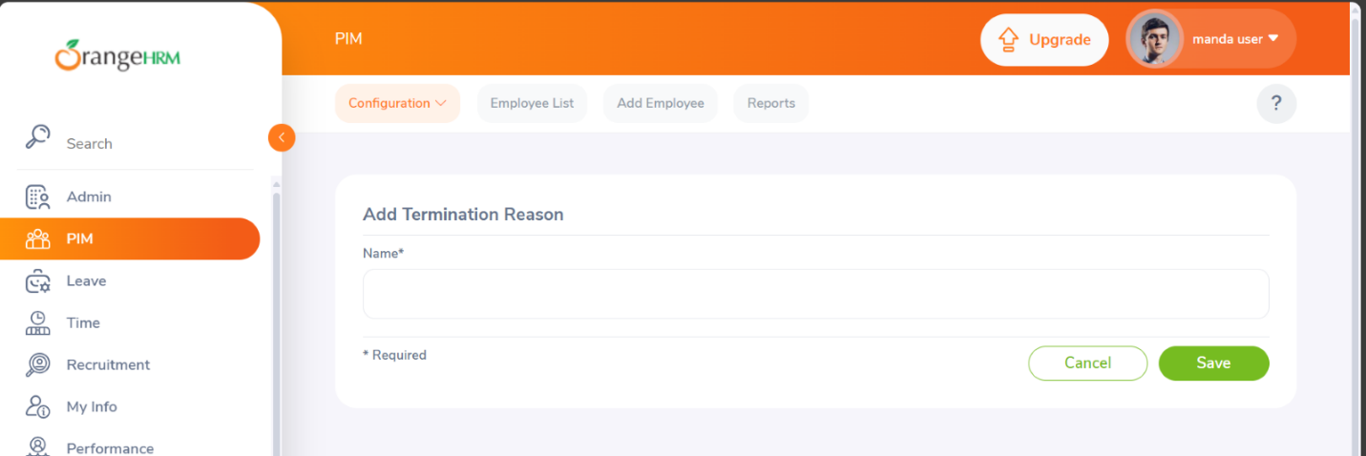

TC\_029

Description: To check whether the Termination Reason input field in accepting text input.

Given the user is logged in to the website “https://opensource-demo.orangehrmlive.com/web/index.php/auth/login” in chrome web browser using the valid username “Admin” and valid password “admin123” and in the “Add” page in “Termination Reasons” tab under “Configuration” dropdown in “PIM” tab.

When the user clicks in the text field

Then the text field should accept user input

TC\_030

Description: To validate the functionality of “Cancel” button on adding to the list on “Termination Reasons”.

Given the user is logged in to the website “https://opensource-demo.orangehrmlive.com/web/index.php/auth/login” in chrome web browser using the valid username “Admin” and valid password “admin123” and in the “Add” page in “Termination Reasons” tab under “Configuration” dropdown in “PIM” tab.

When the user clicks on the “Cancel” button

Then the user should be redirected to the previous page (<https://opensource-demo.orangehrmlive.com/web/index.php/pim/viewTerminationReasons>)

TC\_031

Description: To validate the functionality of “Save” button on adding to the list on “Termination Reasons”.

Given the user is logged in to the website “https://opensource-demo.orangehrmlive.com/web/index.php/auth/login” in chrome web browser using the valid username “Admin” and valid password “admin123” and in the “Add” page in “Termination Reasons” tab under “Configuration” dropdown in “PIM” tab.

When the user clicks on the “Save” button after adding the valid input

Then the inputshould be added to the list and the user should be redirected to (<https://opensource-demo.orangehrmlive.com/web/index.php/pim/viewTerminationReasons>)

Bug Report (Flaky Bug)

Description: The ‘Add’ button is not working few times

**Steps to reproduce:**

* Open chrome browser
* Open the site https://opensource-demo.orangehrmlive.com/web/index.php/auth/login
* Login using username: ‘Admin’ and password: admin123
* From the list select ‘PIM’ then go to ‘Configuration’ then go to ‘Termination Reason’ and click on ‘Add’ button. After entering the reason when the user clicks on save then a few times the data is not added to the list.

Time Stamp: 06/09/2024 11:55 AM

Severity:  Low

Priority: Minor

Assignee: problem\_dev

Expected Result: The input by user should be added to the list all the times.

TC\_032

Description: To validate the functionality of checkbox in the ‘Termination Reasons’ List

Given the user is logged in to the website “https://opensource-demo.orangehrmlive.com/web/index.php/auth/login” in chrome web browser using the valid username “Admin” and valid password “admin123” and in the “Add” page in “Termination Reasons” tab under “Configuration” dropdown in “PIM” tab.

When the user clicks on the checkbox of the termination reason in the list

Then the user should be able to select that specific item from the list on which further functions can be performed that is deletion and updation

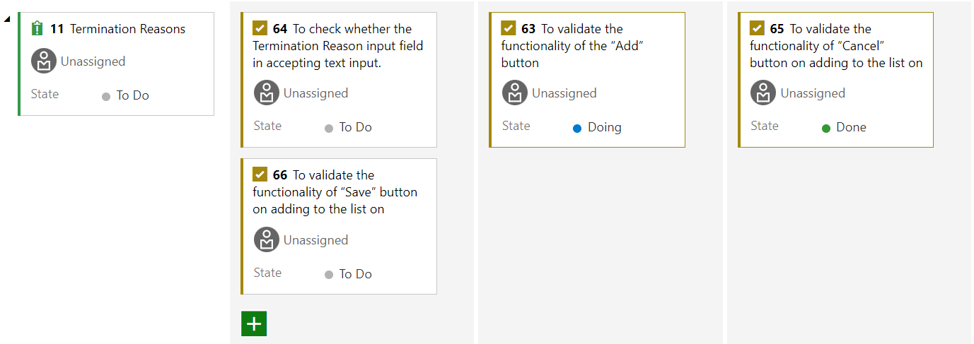

**NAME: PREETI PALLAVI**

Screenshots of Part-1:

CREATING A VIRTUAL MACHINE:

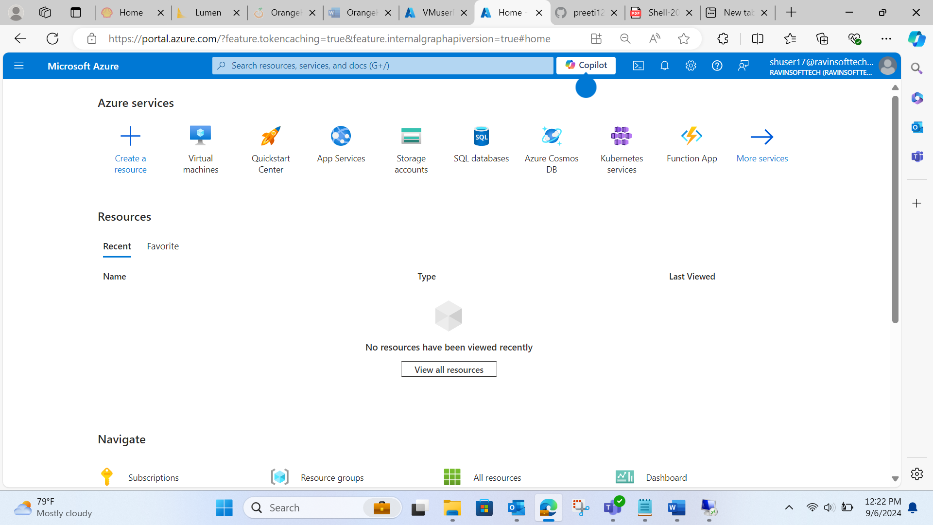

Go to ‘Create a resource’:

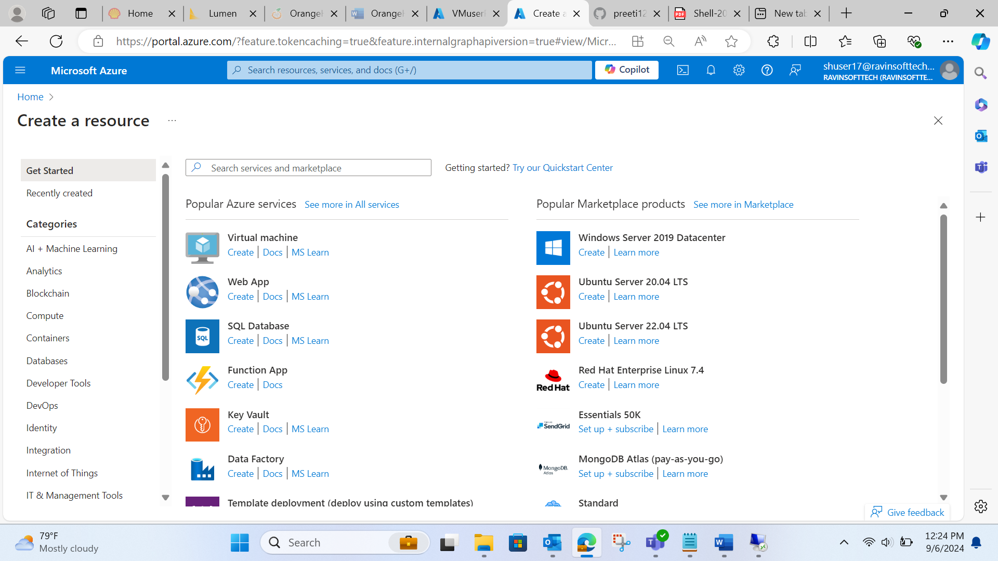

Go to Create under Virtual Machine:

Add all the details of resource group, region , size, username:

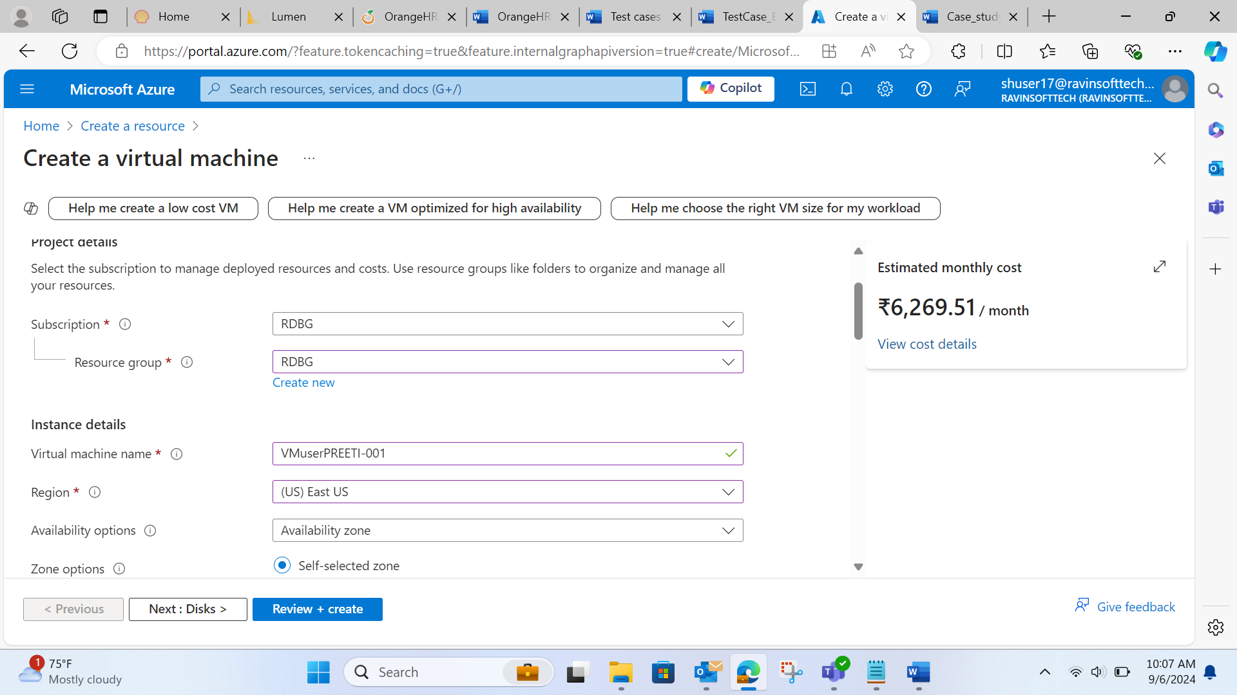

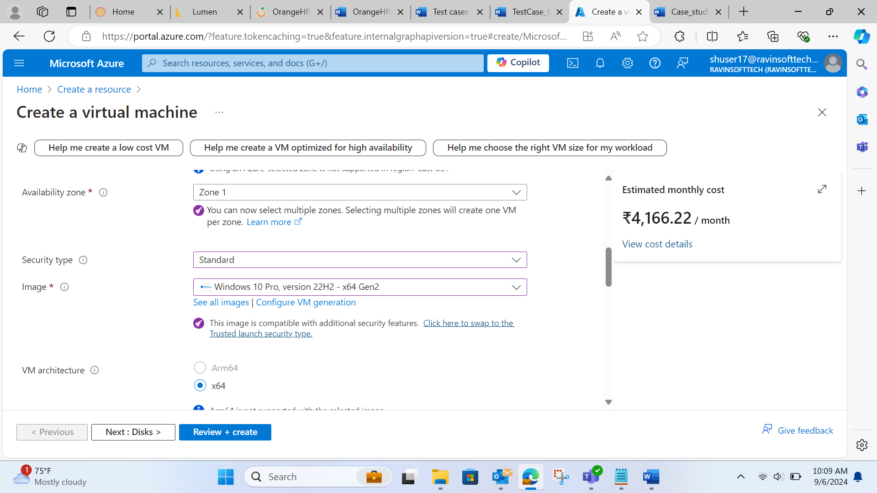

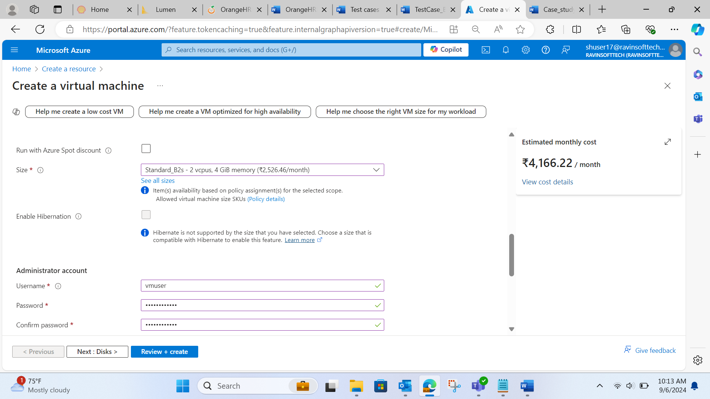

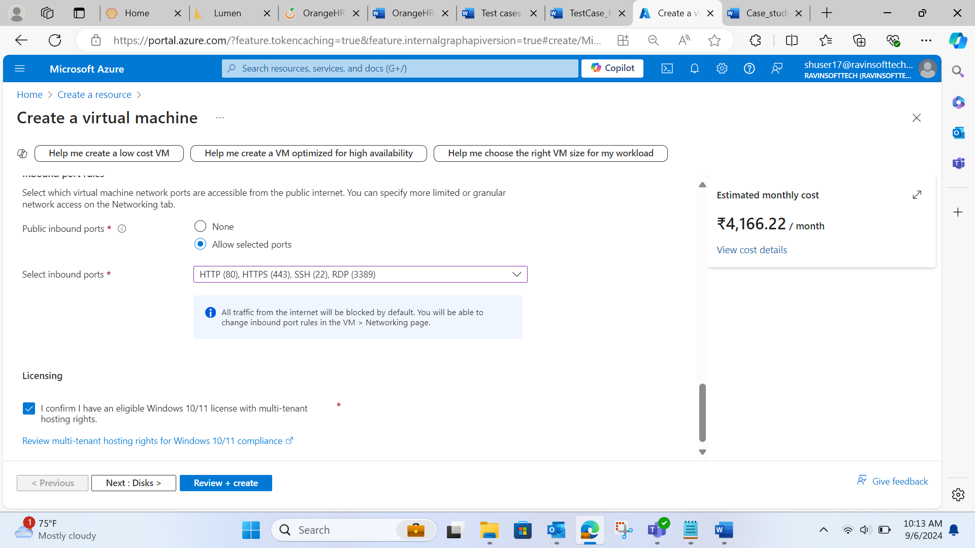

Add the size details, network, subnet:

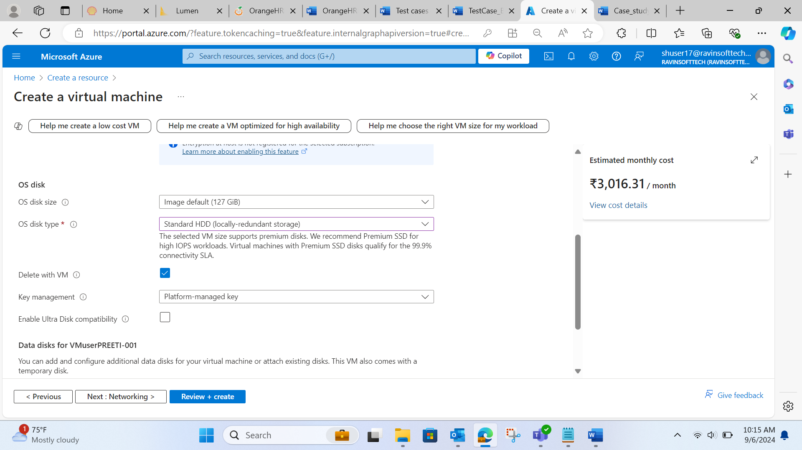

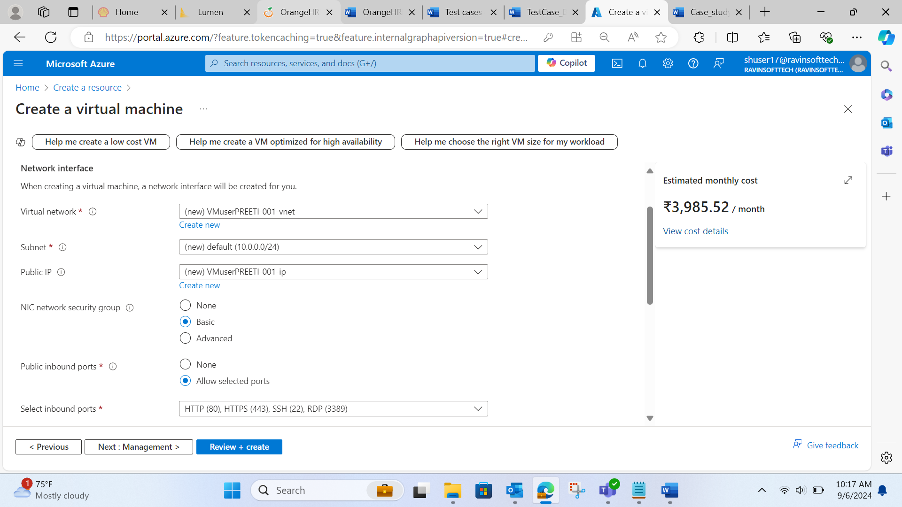

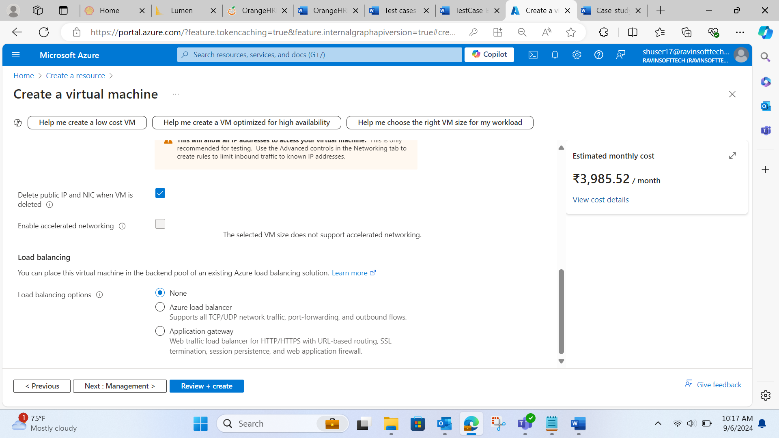

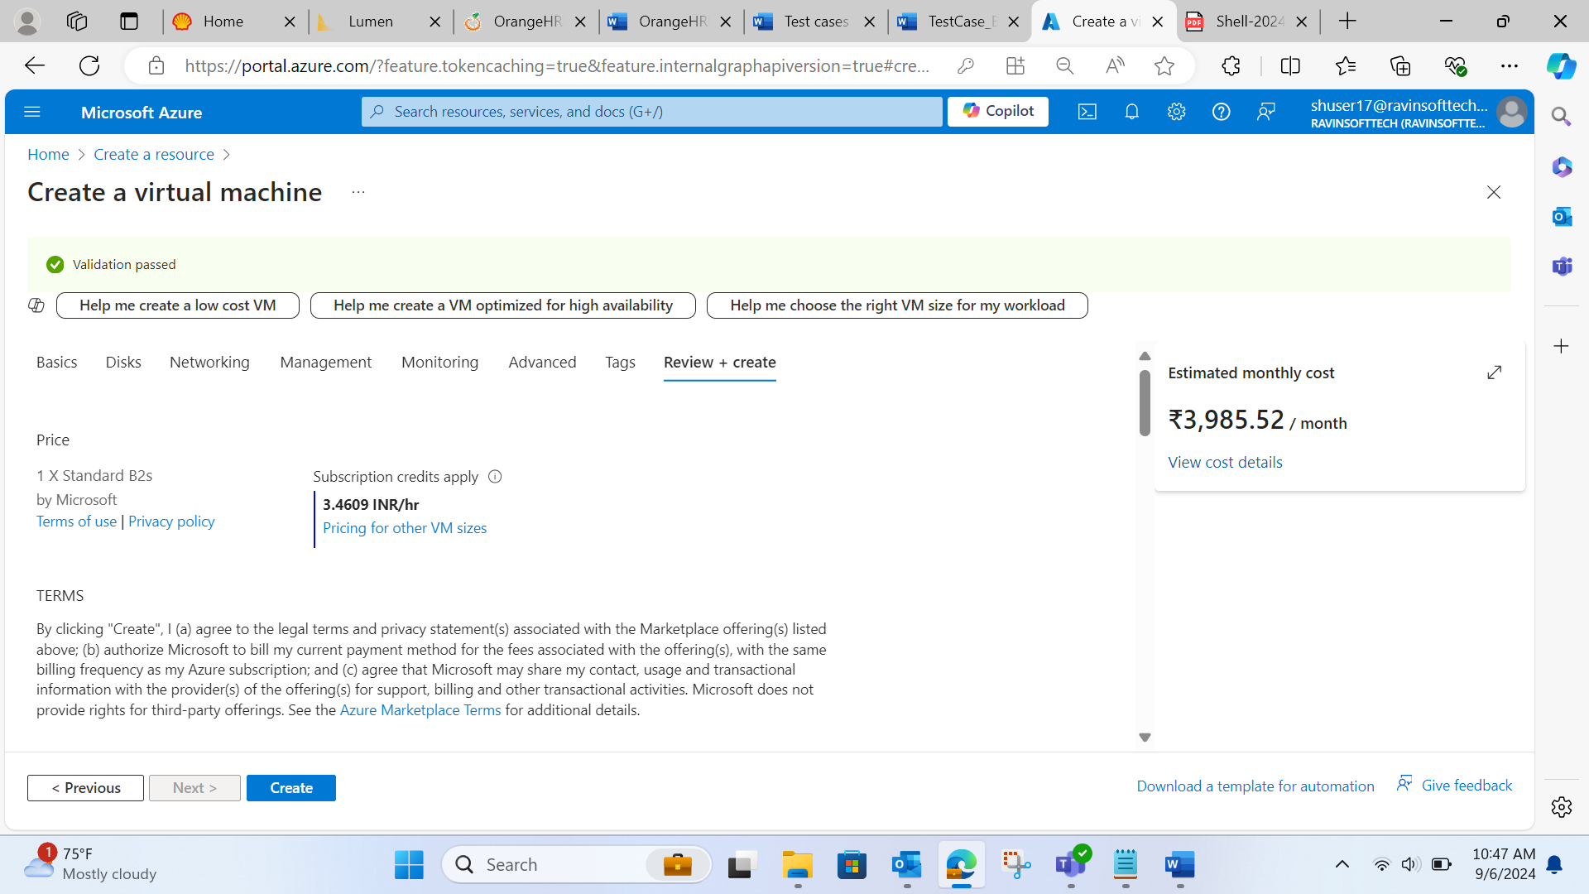

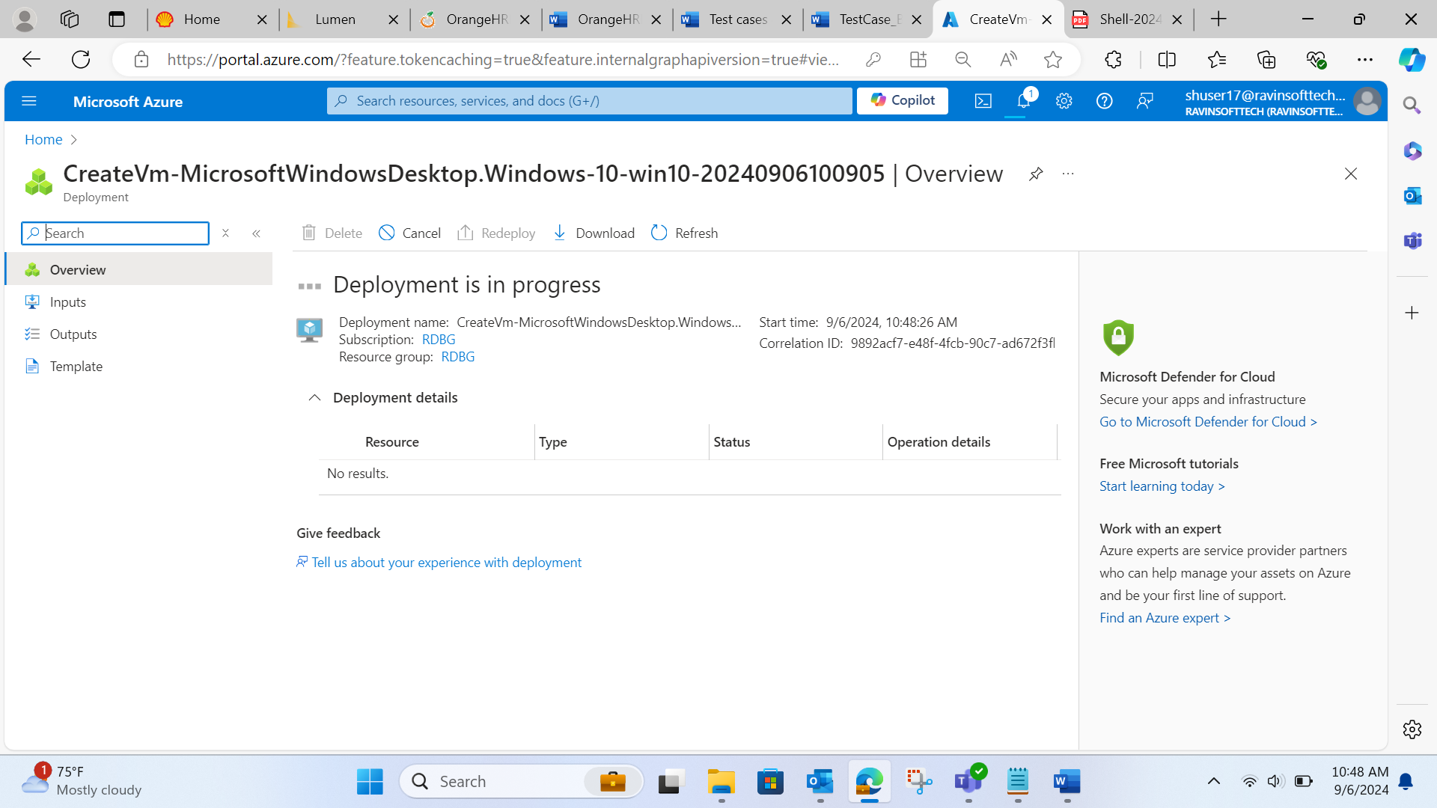

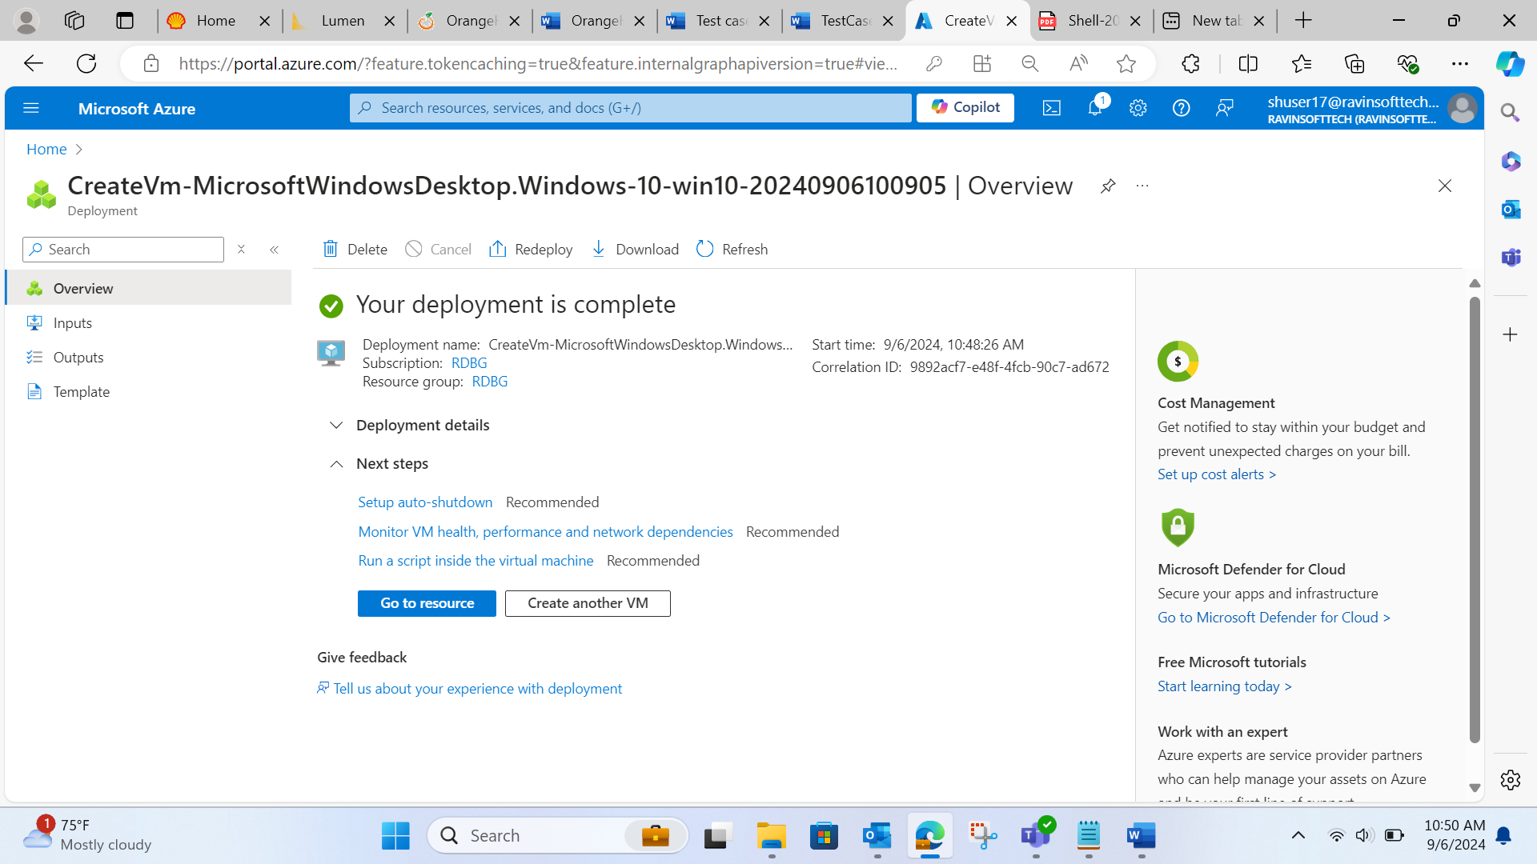

VM is created successfully.

PART -2 : GITHUB CI/CD pipeline creation:

Created a new github repository:

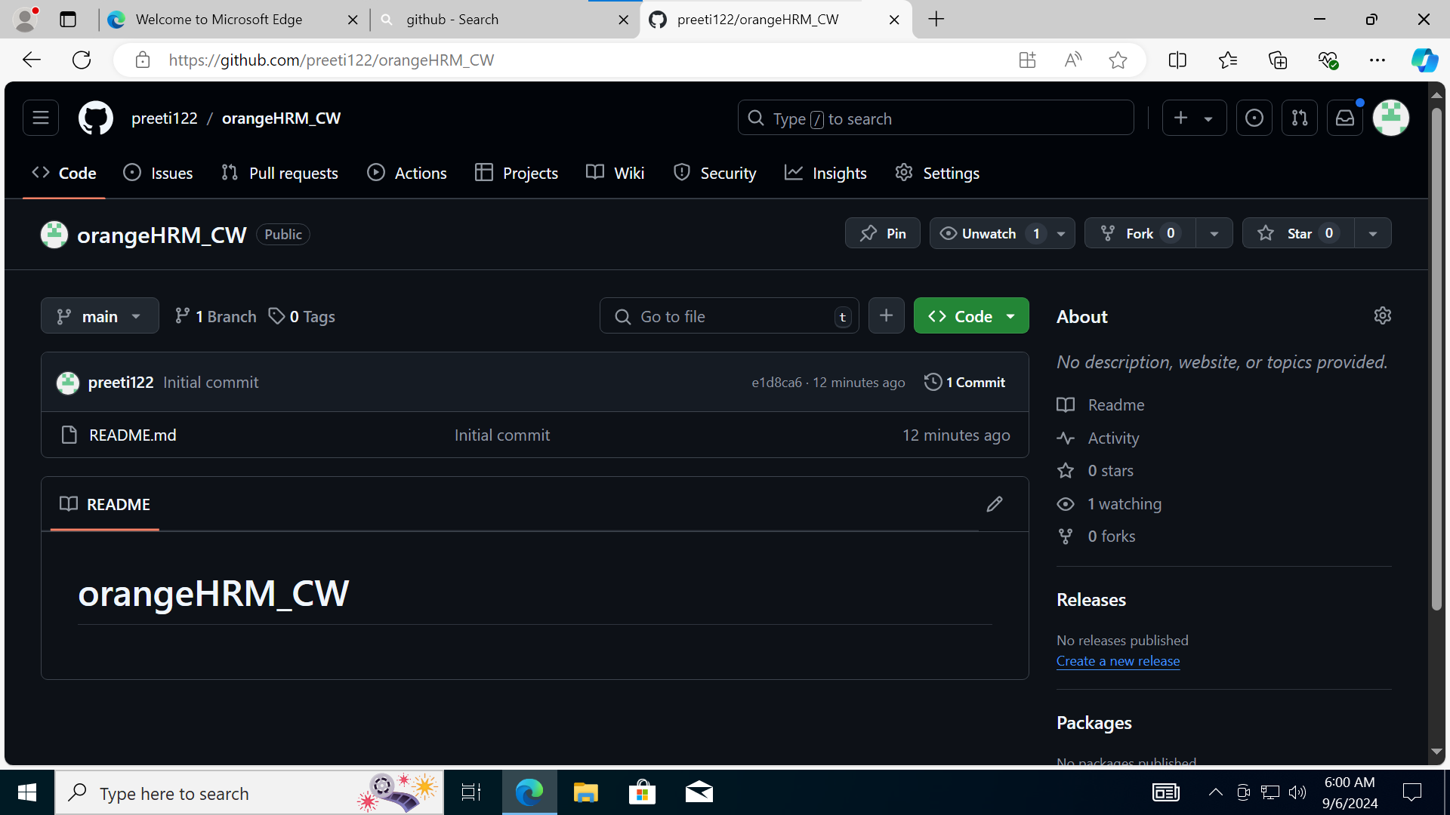

Wrote the basic code for calculating BMI given height and weight in JAVA:

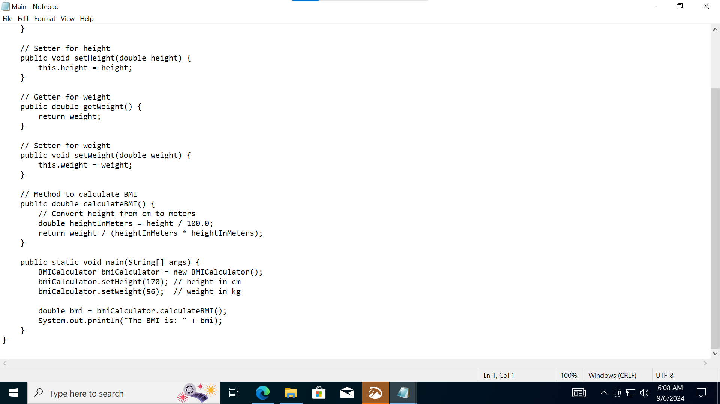

Added Main.java in repo:

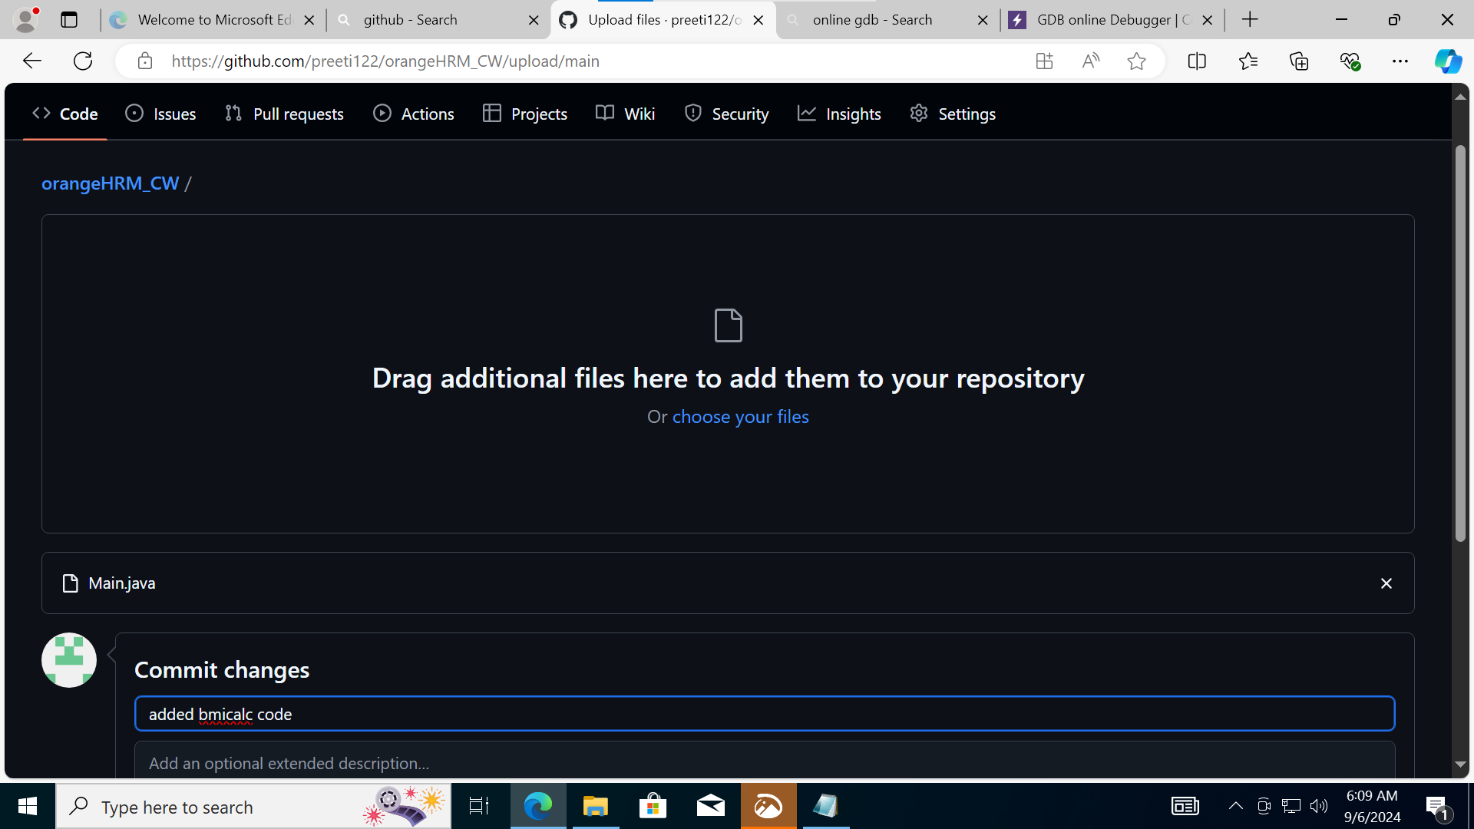

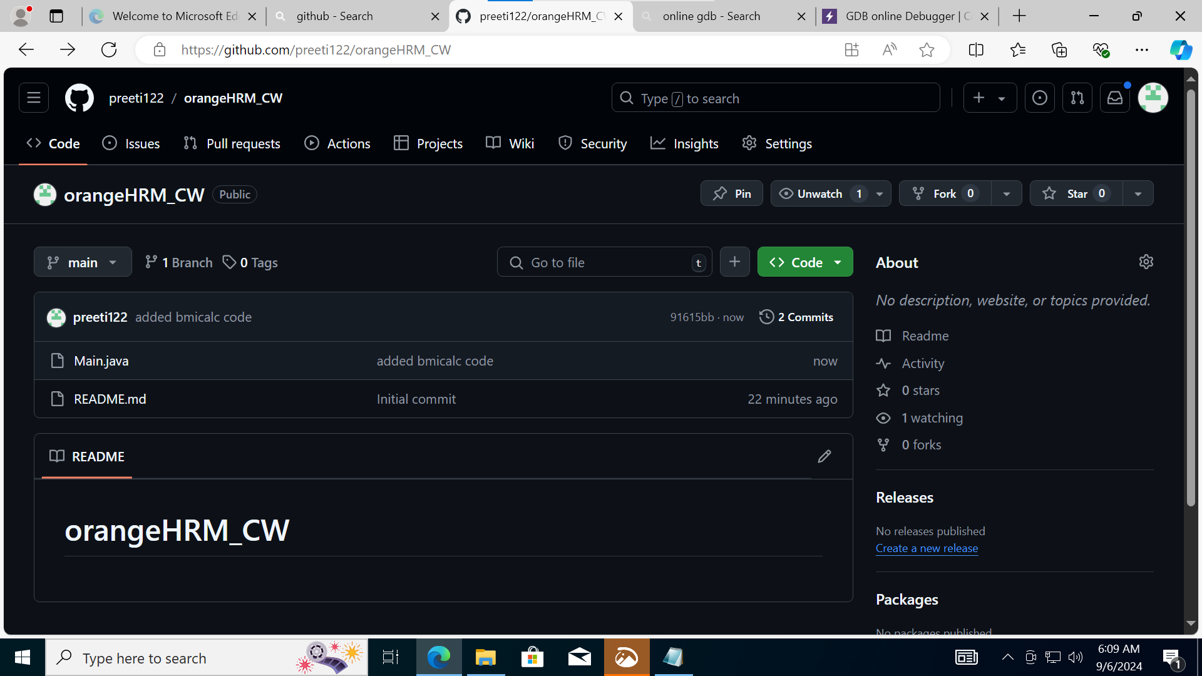

Created a “JAVA with MAVEN” workflow in Github Action and commit the change:

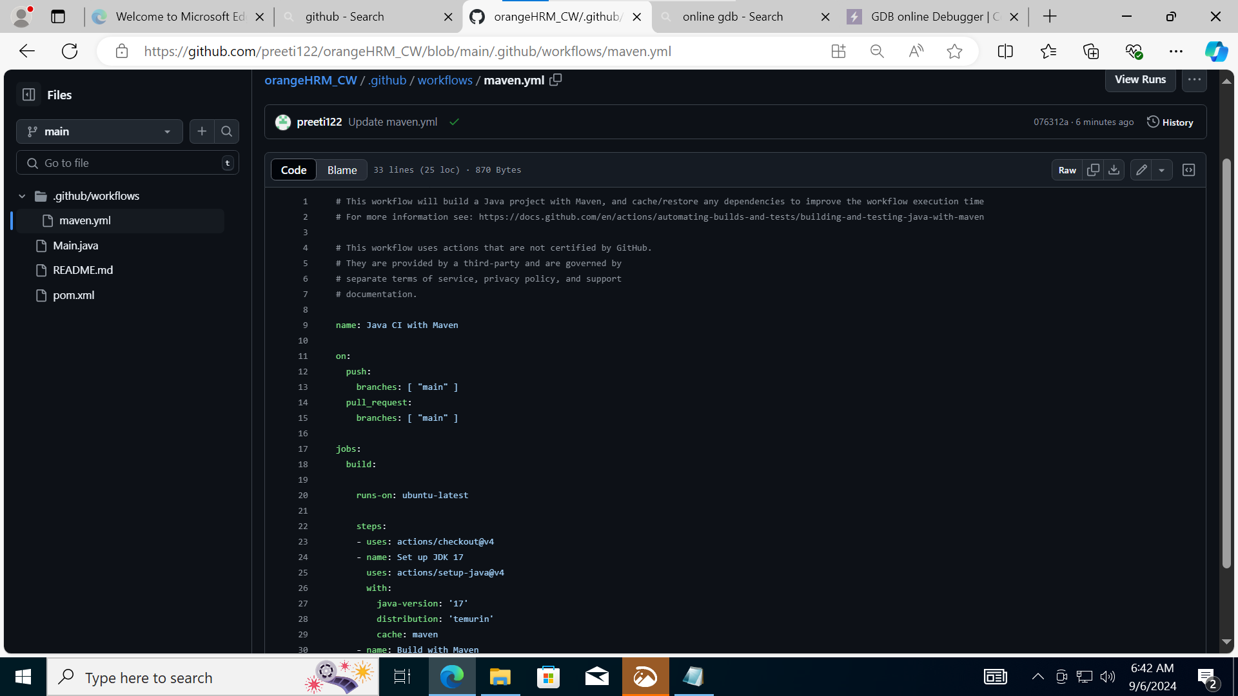

Build successful with maven.yaml:

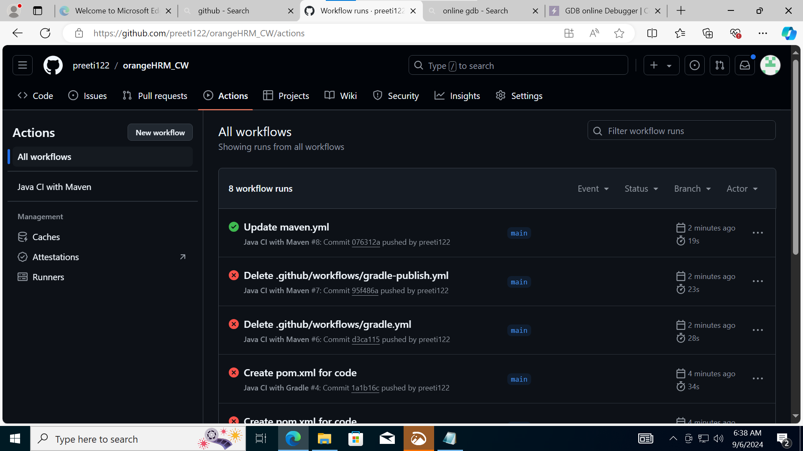

Created a pom.xml file and added it to repo, committed it:

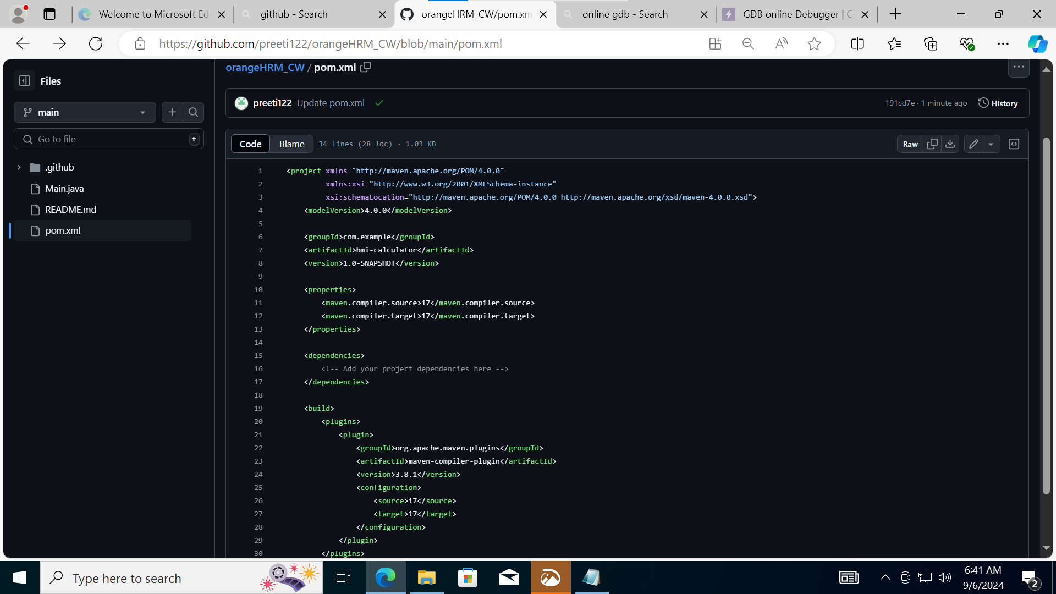

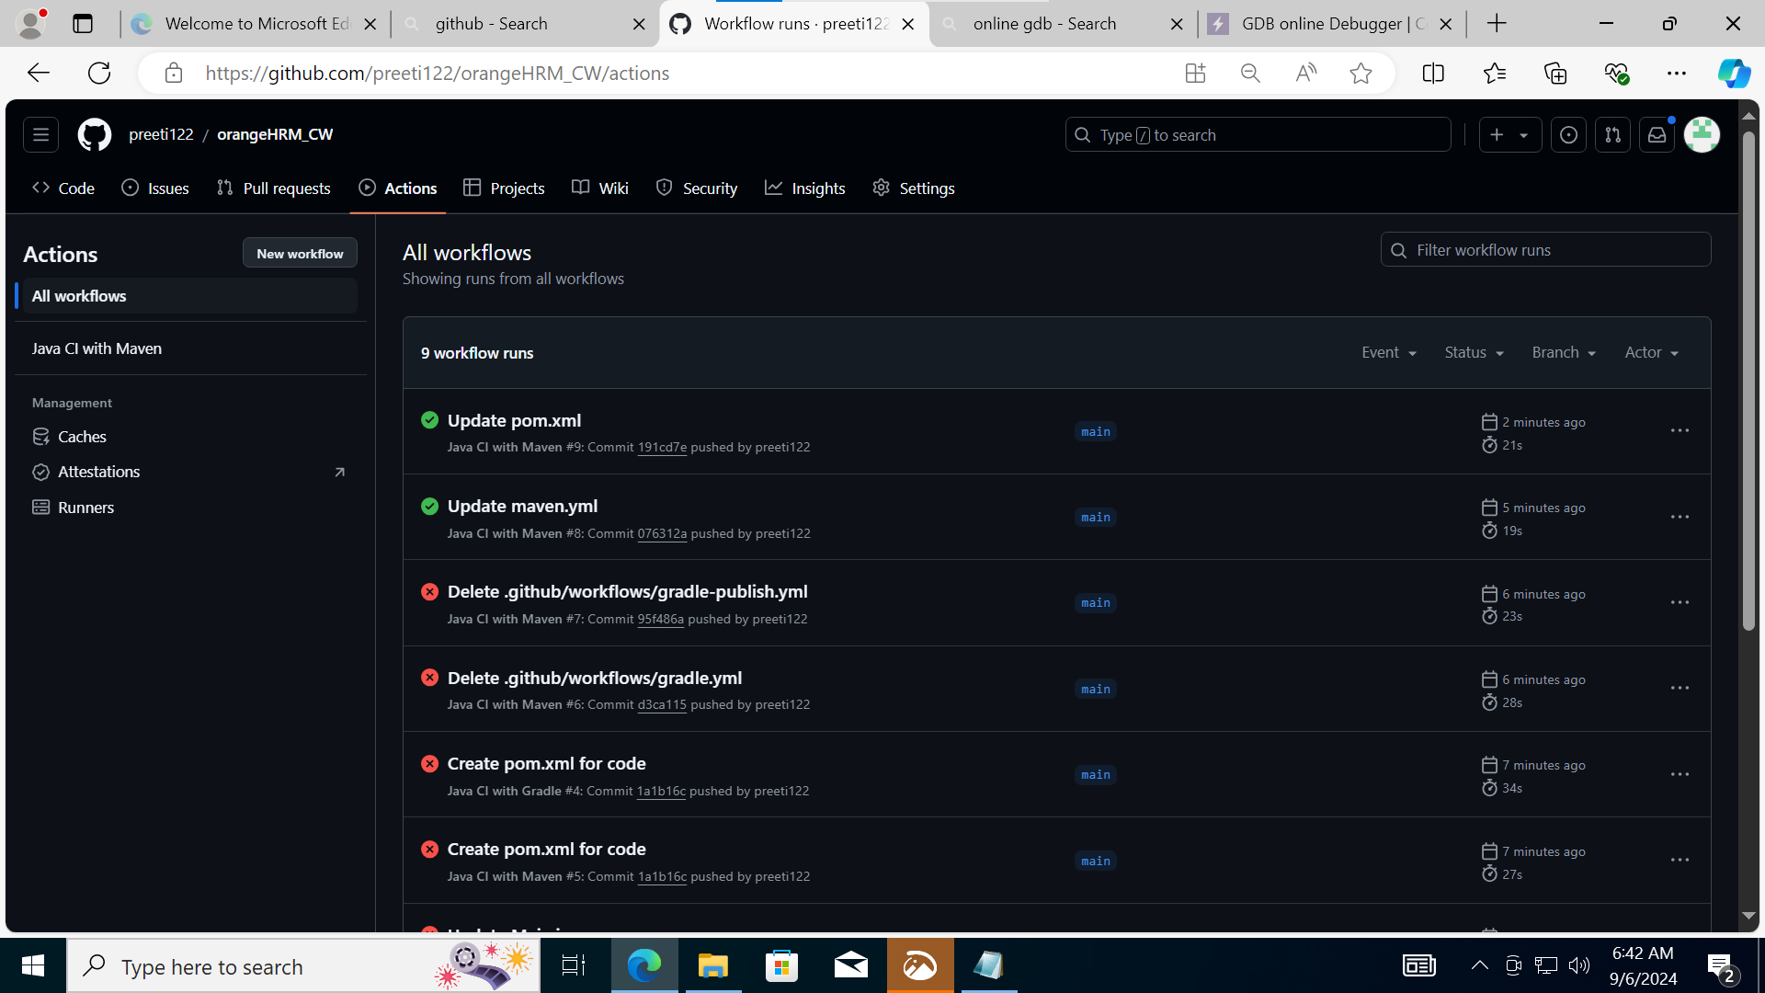

Made some changes in Main.java file:

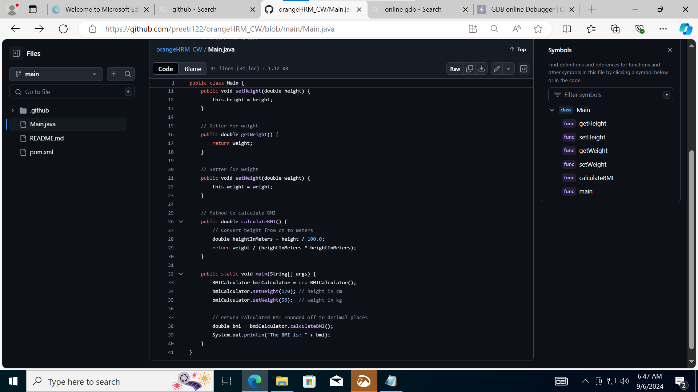

Committed the changes and got successful build:

